This document is merely to point out the differences in confessional count numbers between my findings and the official numbers posted on Survivor Sucks. The guidelines I use can be found [here](https://docs.google.com/document/d/18ofsPiVWxSejzSjEGlU8KEx4Og2ddEJScCV23RsCPIA/edit?usp=sharing).

**Survivor Sucks Season 11 Counts** ([link](https://goo.gl/photos/1ax5zsKK9Ni5wnVt5))

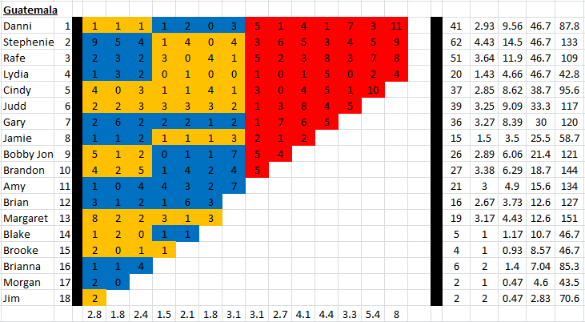

**My Season 11 Counts** ([link](https://photos.app.goo.gl/KgZkeFOZ1JI1nyfF2))

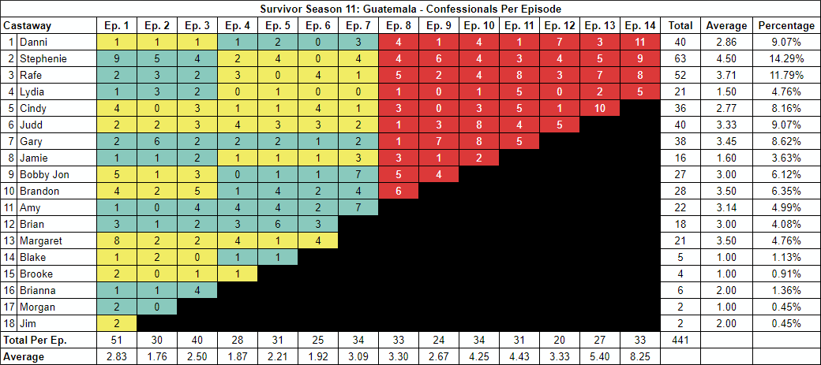

[Survivor Sucks Season 11 thread](http://survivorsucks.com/topic/2818).

**Differences**

[Episode 03](https://docs.google.com/document/d/1lvgarzUwDbCLImZYYSHYdy-jX0xPwGn1e-Am40dw9Yg/edit?usp=sharing)

* **Bobby Jon 3 (+1)** I got a total of 3 confessionals for Bobby Jon instead of the established 2. No significant gaps.
* **Note:** Confessionals #19, #23 & #25 are all on-the-fly confessionals with tribemates on the background. Chyrons are present on #19 & #23. #19 even has Stephenie talking to camera with Rafe sitting right behind her.

[Episode 04](https://docs.google.com/document/d/1psOL4GCNGzo2leKLqbS2gGLlS0-FJhqMcMM3WTdBP7U/edit?usp=sharing)

* **Stephenie 2 (+1)** I got a total of 2 confessionals for Stephenie instead of the established 1. No significant gaps.
* **Judd 4 (+1)** I got a total of 4 confessionals for Judd instead of the established 3. No significant gaps.
* **Brian 3 (+2)** Brian has three consecutive confessionals (10-12). Confessional #11 is the only one with a significant gap of 14s.
* **Margaret 4 (+1)** I got a total of 4 confessionals for Margaret instead of the established 3. No significant gaps.

[Episode 05](https://docs.google.com/document/d/1fAlkBXyCyW2CxscTdRWJczufwOcFV2d8Cyen-2URofo/edit?usp=sharing)

* **Amy 4 (+1)** Confessional #6 has a 12s gap.

[Episode 06](https://docs.google.com/document/d/19S0n1pg-1ejLMQdej3dBLEwD8qp6LhoHsDt1739TqhE/edit?usp=sharing)

* **Margaret 4 (+1)** Confessional #19 is a voice over and has a 10s gap. Also, confessional #22 is part of a dual confessional with Cindy (#21).
* **Note:** Confessionals #3 & #4 are both on-the-fly confessionals. In them, Rafe and Cindy are both looking for firewood and they hold it as they give the confessionals. During Cindy’s, Rafe is seen in the background gathering wood. Both have on-screen chyrons.

[Episode 08](https://docs.google.com/document/d/1uwTyQa3Yur67s4ZOqkjqKlVLPXNt6n9tczQqdh86cz0/edit?usp=sharing)

* **Danni 4 (-1)** Confessional #19 has a 9s gap.
* **Stephenie 4 (+1)** Confessional #23 is an on-the-fly confessional with Stephenie sitting at the pool and her tribemates in the back talking. Chyron present.
* **Jamie 3 (+1)** I got a total of 3 confessionals for Jamie instead of the established 2. No significant gaps.
* **Brandon 6 (+1)** Confessional #31 has an 11s gap.
* **Note:** Confessional #14 is an on-the-fly Lydia confessional as she paints the merge flag. Chyron present.

[Episode 10](https://docs.google.com/document/d/1mLREPLqnqP1HiAtc2YFSqvB_LM_mVsoAVanJqDn_aC4/edit?usp=sharing)

* **Stephenie 4 (-1)** Confessional #8 has a 9s gap.
* **Rafe 4 (+1)** Confessional #32 has a 10s gap.
* **Cindy 3 (-1)** Confessional #3 has a 9s gap.
* **Gary 8 (+2)** Confessionals #20 & #21 both have 12s gaps.

[Episode 14](https://docs.google.com/document/d/1ho2n-3bR2LQx1jTRWQy5AcjCcZO12a-q8vfJ5Nrq0ww/edit?usp=sharing)

* **Lydia 5 (+1)** Confessional #8 has a 10s gap, and confessional #9 is a voice over.

**No Change**

* [Episode 01](https://docs.google.com/document/d/1aQyvdtFKWGb6YubW9eEAeRUMIq0zqr4MaG1OKSXYKUg/edit?usp=sharing)
  + **Note:** Confessional #20 is an on-the-fly Blake confessional after he collapses from dehydration and sits next to a tree. Chyron present.
* [Episode 02](https://docs.google.com/document/d/1tyVzKeM2MtpcUx41AIZ_qzkhMqrSLMna2anoiRpOlF0/edit?usp=sharing)
  + **Note:** Confessionals #14 & #21 are two on-the-fly confessionals with Lydia & Rafe, respectively, next to the river and talking to the camera.
* [Episode 07](https://docs.google.com/document/d/1qo20UGtSuxJj94UkUfbUGD7n6R_RALjqxhHsNPleL5k/edit?usp=sharing)
* [Episode 09](https://docs.google.com/document/d/1elwMsyCm0QFWW_TYnucwp2JVBgilla95aq-t9bg_-YY/edit?usp=sharing)
* [Episode 11](https://docs.google.com/document/d/1UtRWh_dS4XsJs8jqjyMRddzXSrQDlz7t9K3JEyxUGEU/edit?usp=sharing)
* [Episode 12](https://docs.google.com/document/d/1MGUANpt7zgfliPzxl_iznNaV8NNlXqximZRzX7K6jb0/edit?usp=sharing)
  + **Note:** Mindy (Cindy’s twin sister) has a dual confessional (first one) with Cindy sitting beside her (not talking). However, it is questionable if the last sentence said off-camera was done by Mindy or Cindy. I gave full credit to Mindy.
* [Episode 13](https://docs.google.com/document/d/1I_VUk7VcQgYgstwGe1WzmuoAm3FEGIYgZhEqHRB6t8M/edit?usp=sharing)
  + **Notes:**
    - Confessional #8 has on-the-fly elements, specifically, the end where Lydia talks directly to the camera as she’s sitting at camp. No chyron.
    - Confessional #23 is an on-the-fly Stephenie confessional where she talks to the camera as she hangs the Immunity Necklace on a tree. No chyron.

|  |  |  |
| --- | --- | --- |
| **Castaway** | **Count** | **Change** |
| Danni | 40 | -1 |
| Stephenie | 63 | +1 |
| Rafe | 52 | +1 |
| Lydia | 21 | +1 |
| Cindy | 36 | -1 |
| Judd | 40 | +1 |
| Gary | 38 | +2 |
| Jamie | 16 | +1 |
| Bobby Jon | 27 | +1 |
| Brandon | 28 | +1 |
| Amy | 22 | +1 |
| Brian | 18 | +2 |
| Margaret | 21 | +2 |
| **Total** | **441** | **+12** |

**Revised Sucks Counts** (link)